LAB 3: TO IMPLEMENT LOGIC OPERATION USING MUX IC

Name: Shreyas Sawant Div: D7A Roll No.: 55

4:1 Multiplexer

On Switch Board

1-> S1

2-> S0

3-> I0

4-> I1

5-> I2

6-> I3

S1=0 S0=0 I0=1

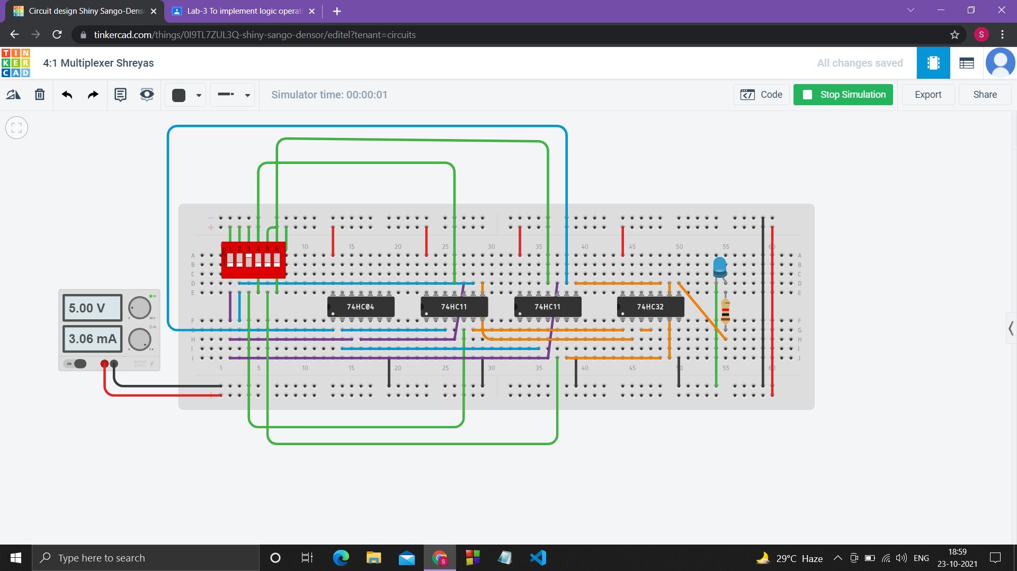

S1=0 S0=1 I1=1

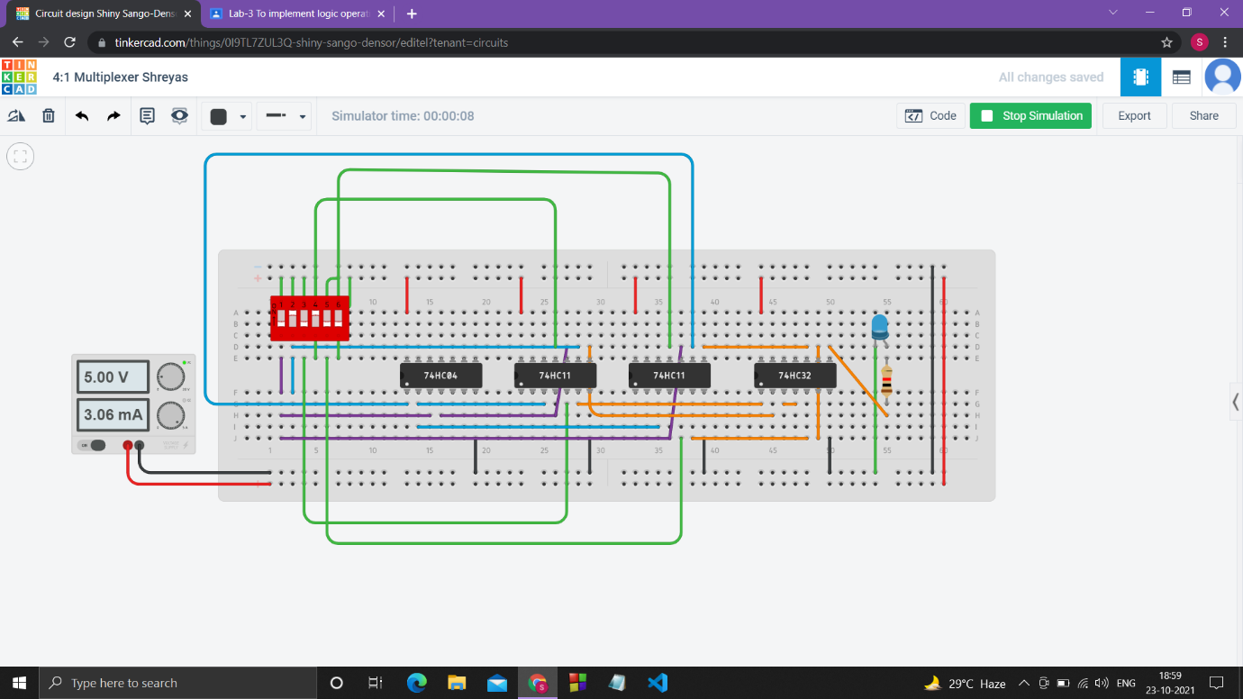

S1=1 S0=0 I2=1

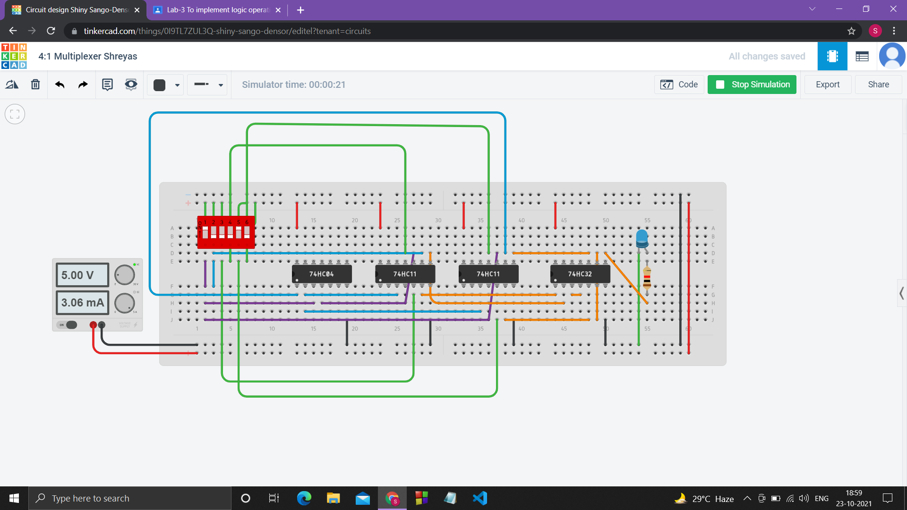

S1=1 S0=1 I3=1

